Experiment No-6
Online Cake ordering System
AIM:
To develop an online cake ordering website using HTML, CSS, and JavaScript to browse and select cakes based on categories, flavors, and prices. The system allows users to add cakes to the cart, place orders, manage delivery details, and track order status.
Procedure:
- Create an HTML page to display cakes and their prices.
- Apply CSS to design the webpage.
- Use JavaScript to select a cake and calculate the total price.
- Display the order confirmation.
- Run the program in a web browser.
Sample Code:
<!DOCTYPE html>
<html>
<body>
<h2>Cake Ordering System</h2>
<select id="cake">
<option value="300">Chocolate Cake - Rs.300</option>
<option value="500">Black Forest Cake - Rs.500</option>
<option value="400">Vanilla Cake - Rs.400</option>
</select>
<button onclick="order()">Order Cake</button>
<p id="result"></p>
<script>
function order() {
let cake = document.getElementById("cake");
document.getElementById("result").innerHTML =
"Order placed! Total: Rs." + cake.value;
}
</script>
</body>
</html>
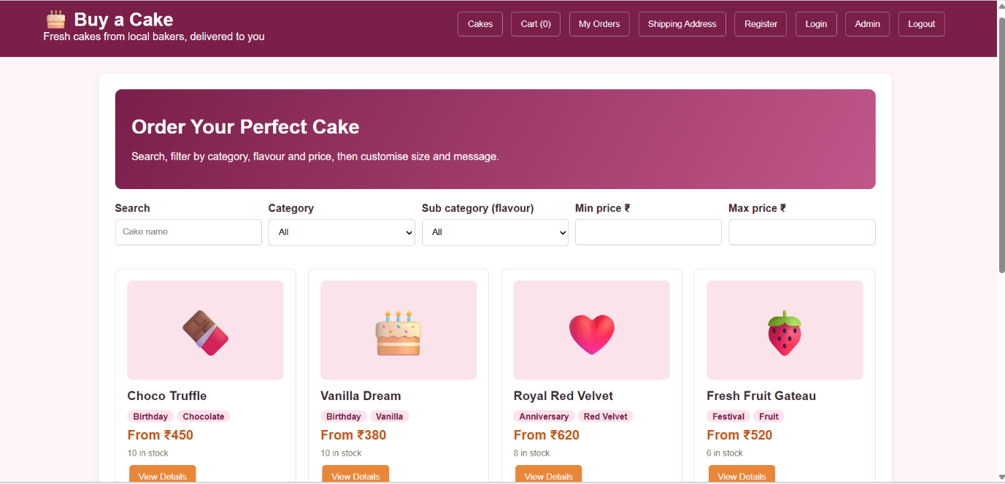
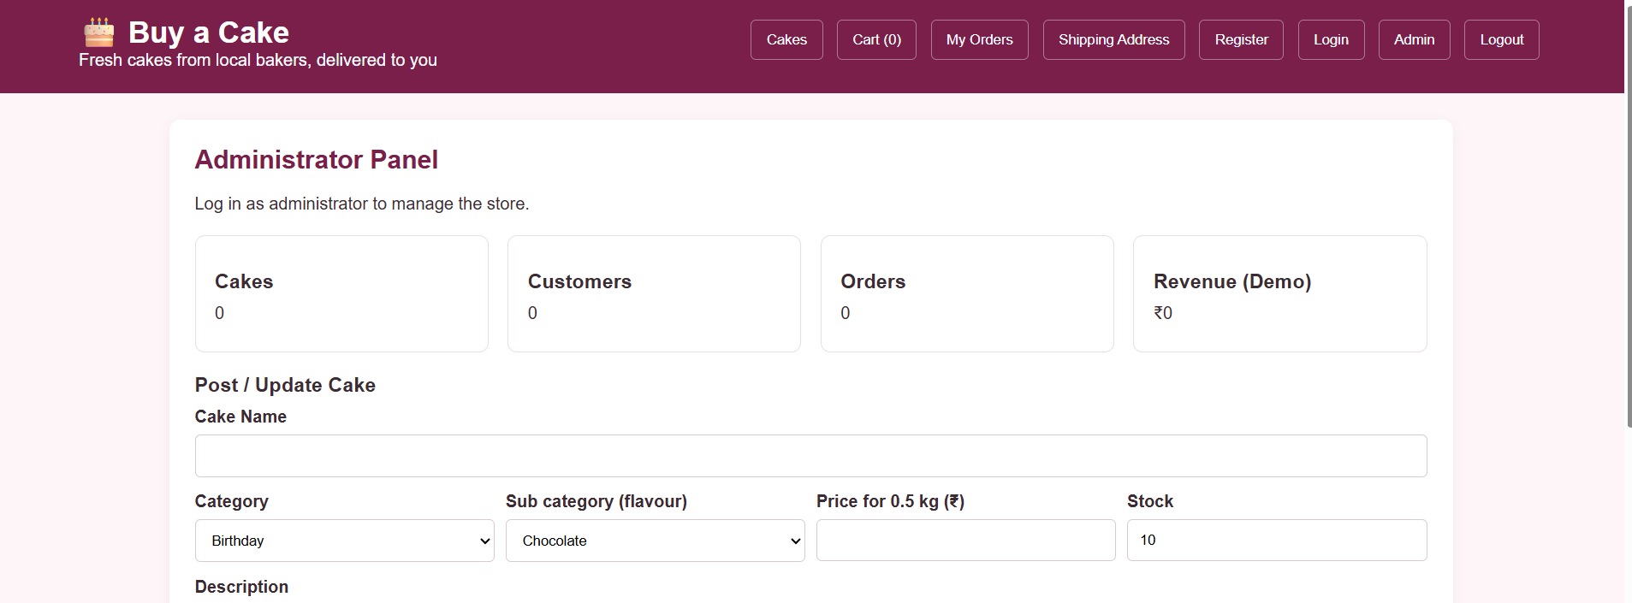
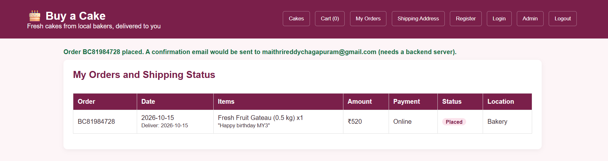
Result:
Thus, the cake ordering website was developed successfully to display cakes, select cakes, and show the order amount.

